Knowledge Garden

A Web Application that store the issues, new experience that the UI/SD developers faced during work.

Include Search feature, so other Company members can gain this information easily and prevent the wasting of time trying to solve the same issue.

1. **Application Description:**
   1. The application consists of 4 screens
      1. User registration
      2. Login screen
      3. Add/Edit/View info Screen
      4. Search Grid

User registration Screen

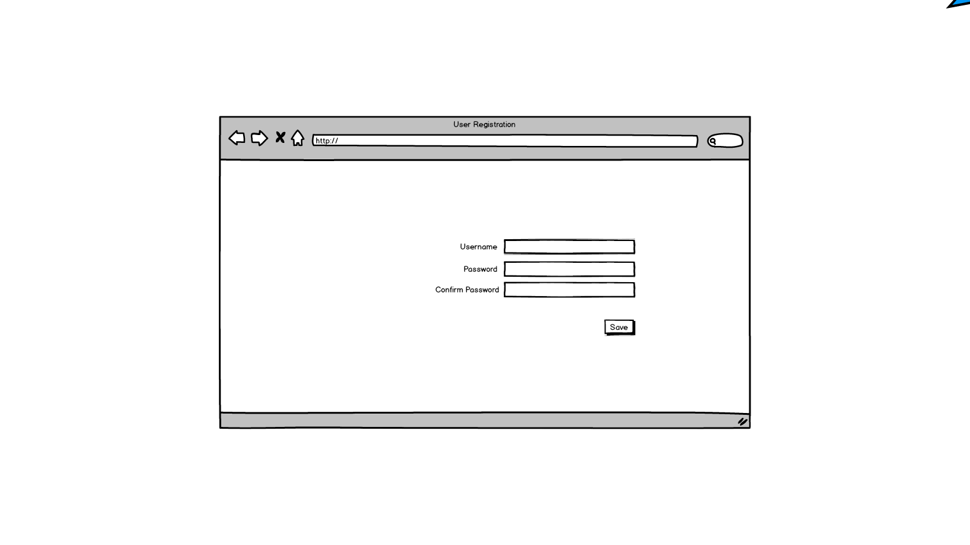

|  |  |
| --- | --- |
| Screen name | User registration Screen |
| user | Anyone can open this screen |
| Scenario | 1. user enter the username, password, & the Confirm Password    1. if the password & Confirm Password don’t match       1. display note [The Passwords don’t matching ] 2. when user click save, the system store the data of the new user |
| Fields | 1. Username: string, max length 20 character, don’t accept the special characters [only the dot]. **[Required]** 2. Password: string, max length 20 character, accept the special characters **[Required]** 3. Confirm Password: string, max length 20 character, accept the special characters **[Required]** 4. Save button |

Login Screen

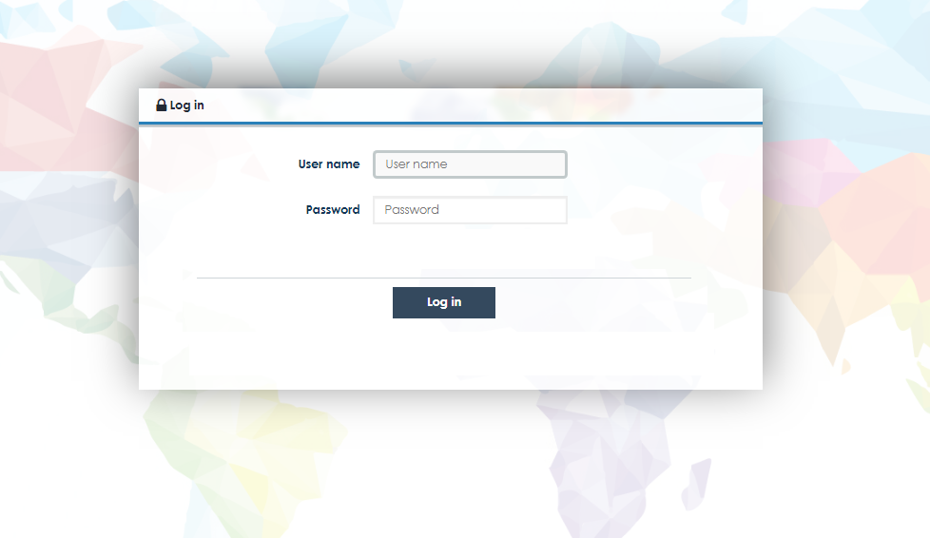

|  |  |
| --- | --- |
| Screen name | Login Screen |
| user | Anyone can open this screen  Only authenticated users can login |
| Scenario | 1. User enter user name & password 2. If Valid the system redirect to the[ Search Grid] screen 3. If not Valid ,the System display message [invalid username OR Password] |
| Fields | 1. Username: string, max length 50 character, accept the special characters **[Required]** 2. Password: string, max length 50 character, accept the special characters **[Required]** 3. Save button |

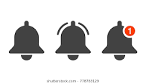Add/Edit/View info Screen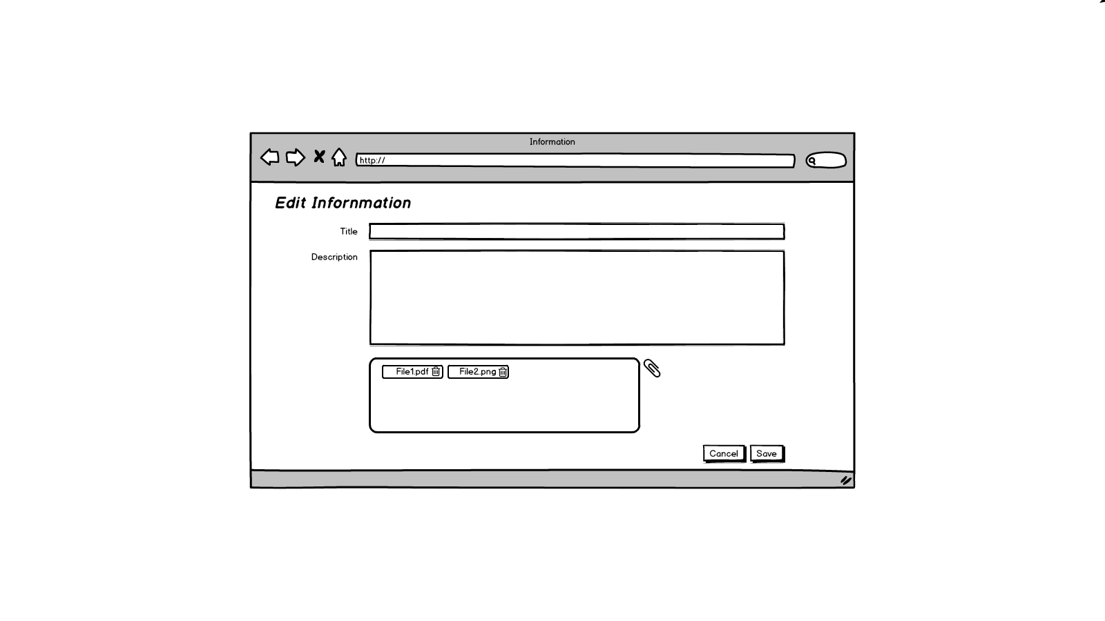

|  |  |
| --- | --- |
| Screen name | Add/Edit/View information |
| user | authenticated users can open this screen |
| Modes | Add: -All authenticated users can add  -user can edit title/description /attach files/ delete files  Edit: -only the user that created the info can Edit it  -user can edit title/description /attach files/ delete files  View: -All authenticated users can View  -user can’t view Title/ description/ download files |
| Links | 1. User click on add in the Search Grid screen [Add Mode] 2. User Click on an Information Title in the Grid Screen [Edit/View Modes] |
| Scenario | 1. The screen title changed according to Mode    1. If View Mode🡺 Screen Title [View Information]    2. If Edit Mode🡺 Screen Title [Edit Information]    3. If Add Mode🡺 Screen Title [Add Information] 2. Case Add/Edit Mode    1. User fill the required fields    2. Attach file, delete, download file    3. Click save, the system save the new/Edit information    4. Click Cancel , the system redirect to the [Search Grid] Screen 3. Case View Mode    1. User can download file    2. Click Cancel , the system redirect to the [Search Grid] Screen 4. When other user add a new knowledge the system display notification[use push notification] |
| Fields | 1. Title: string, max length 100 characters, accept the special characters **[Required]** 2. Description: string, max length 1000 characters, accept the special characters **[Required]** 3. Attachments 4. Save button [**only in Add/Edit mode]** 5. Cancel button |

Search Grid

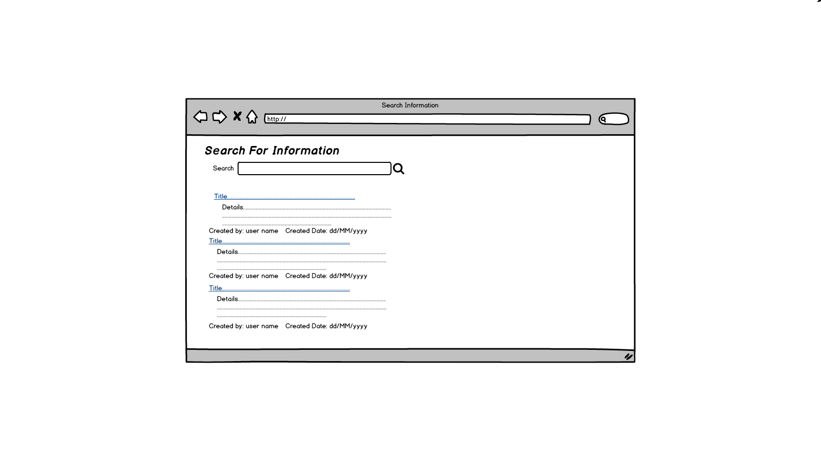

|  |  |
| --- | --- |
| Screen name | Search Grid |
| user | authenticated users |
| Scenario | 1. If no key word entered &user click search, system do nothing 2. User enter key words in the search text box& click search 3. The system search for the entered text as separate words in the title and the description fields 4. By default the system display the first 10 records that contains these key words 5. When user scroll down, the system display the next 10 records. 6. When user click on the title link, system redirect to the [Information Screen] 7. When other user add a new knowledge the system display notification[use push notification] |
| Fields | 1. Search Textbox : max length 100 characters **[Required]** 2. Search button |